**Linux Assignment 4**

1. What is the use of filter commands

* Filter commands is used by filter the data, change the data, eliminate duplicate data and copy the data
* Filter commands are head, tail, sort, pipeline, cat, uniq, sleep, find, cut, grep, sed, tr and awk

1. What is the use of awk

* Awk is used by the text processing and it is a powerfull command in linux
* Awk is used by scans a file line by line
* Awk is used by splits a file into multiple fields
* In awk, we are searched specified text in a file

1. What is the use of sed

* Sed stands for Stream Editor
* Sed is used by change the data
* Sed is used by delete the content
* In sed, whatever you replace the nth line in file it will replace

1. Execute all commands and prepare a ppt along with a screenshot

Head- it will print the top of the file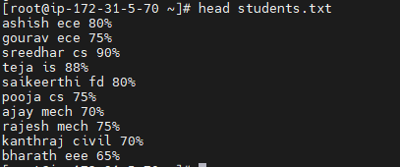

head -4 students.txt or head -n 4 students.txt

Tail – it will print the bottom of the file

tail -n 3 <file-name> or tail -3 <file-name>

Pipeline command

* Passing a output of 1st command as an input to 2nd command

Sort

* It is used to display the data in Ascending to Descending order and Descending to Ascending order

sort <file-name>

sort -r <file-name>

sort -n <file-name> based on numbers

uniq

* It is used to eliminating the duplicate data from the file

uniq <file-name>

uniq -c <file-name>

we can get the information of duplicate data’s number of occurrence

uniq -d <file-name>

* We can get the only duplicate data from the file

cat

* It is used to copy the data from one file to another file

Cat <source-file> > cat <destination-file>

Cut

* It is used to get the position of the char

Cut -b numer <file-name>

Find

* It is used to get or find the file

find <file-name>



Sleep

* It is used by particular or specified timings

sleep 15 | echo “Sai Sreedhar Goud”



Grep – Global Regular Expression Print

grep <search-word> <file-name>



Tr - Translate  
* It is used to get translate the data

echo “sai” | tr sai SAI



Sed – Stream Editor

1. Changing the data

sed ‘s/old-file/new-file/’ <file-name>

Print the data

sed ‘s/old-file/new-file/p’ <file-name>

Replace the nth line

sed ‘nthline s/old-file/new-file/’ <file-name>

sed ‘3 s/cs/ece/’ students.txt

Print the replace nth line

sed ‘nth line s/old-file/new-file/p’ <file-name>

sed ‘3 s/cs/ece/p’ students.txt

Delete the line or content

sed ‘2d’ <file-name> or sed ‘2d’ students.txt

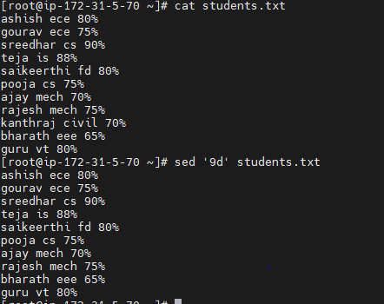

Pipeline command using change the data

Echo sai | sed ‘s/sai/goud/’



Awk

Print particular line

awk ‘/option/ {print}’ <file-name>

awk ‘/cs/ {print}’ students.txt



Print the specified column

awk ‘{print $n}’ <file-name>

awk ‘{print $1}’ students.txt

Print the numbers

Awk ‘{print NR,$n}’ <file-name> or awk ‘{print NR,$0}’ students.txt

